**Project Initialization and Planning Phase**

|  |  |
| --- | --- |
| Date | 10 July 2024 |
| Team ID | 739695 |
| Project Name | Predicting the Compressive Strength of Concrete |
| Maximum Marks | 3 Marks |

**Define Problem Statements (Customer Problem Statement Template):**

The project aims to develop a predictive model for accurately estimating the compressive strength of concrete based on its mix proportions and curing conditions. The model will identify key factors influencing strength and use machine learning techniques to make precise predictions. This will help optimize concrete mix designs, ensuring safety and performance in construction while minimizing costs. The outcome will be a valuable tool for civil engineers and construction professionals.

Predicting the compressive strength of concrete is crucial for ensuring structural integrity and durability. This strength is influenced by mix proportions, curing conditions, and environmental factors. Traditional testing methods are labor-intensive , but machine learning offers efficient alternatives by analyzing data to identify patterns and make accurate predictions. Techniques like regression, decision trees, and neural networks can optimize mix designs, ensuring safety and cost-effectiveness in construction.

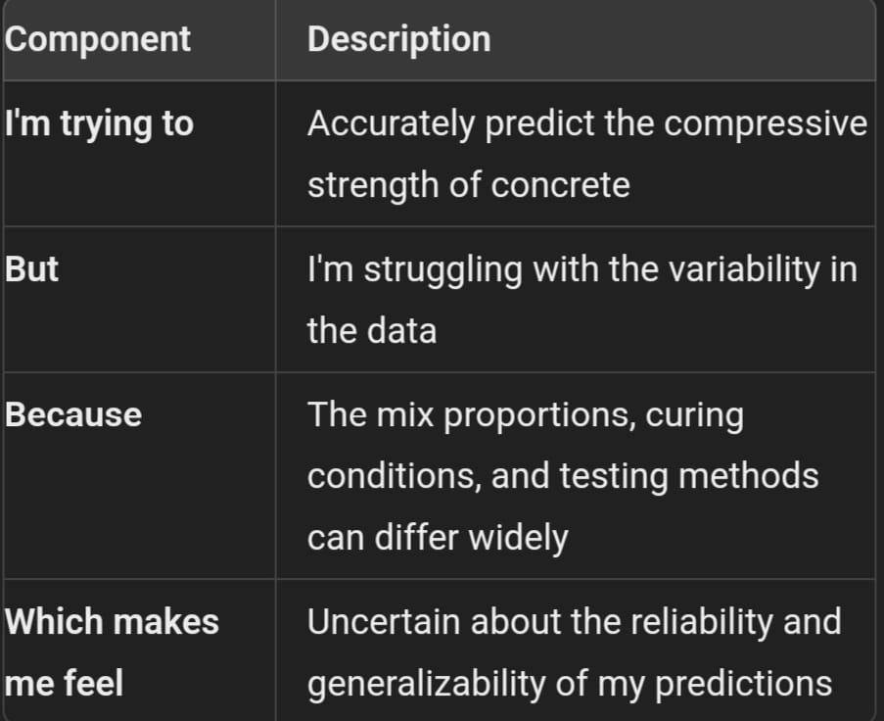



Reference: https://miro.com/templates/customer-problem-statement/

**Example: predicting compressive strength of concrete**

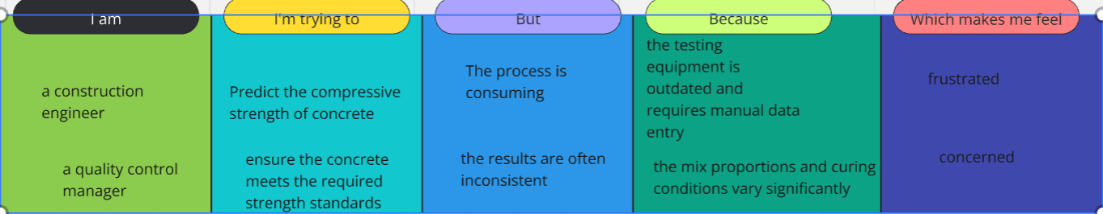

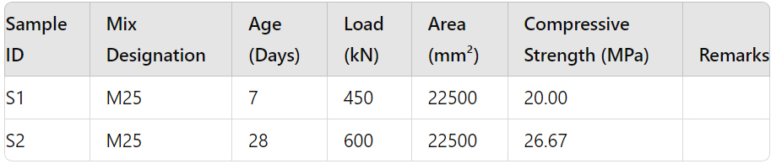

|  |  |  |  |  |  |
| --- | --- | --- | --- | --- | --- |
| **Problem**  **Statement**  **(PS)** | **I am**  **(Customer)** | **I’m trying to** | **But** | **Because** | **Which makes me feel** |
| PS-1 | A construction engineer | Predict the compressive strength of concrete | The process is time -consume | The testing equipment is outdated and requires manual data entry | frustrated |
| PS-2 | A quality control manager | Ensure the concretemeets the required strength standards | The results are often incosistent | The mix proportions and curing conditions vary significantly | concerned |